WHISTLEBLOWER / VIGIL MECHANISM POLICY
- INTRODUCTION
  - The purpose of this policy is to establish a vigil mechanism through the “Whistleblower Policy” (“the Policy”) for Directors and employees of Rockman Industries Limited (hereinafter referred to as “Company”) to report concerns of unethical behavior, actual or suspected fraud, or violation of the Company’s Code of Conduct.
  - Rockman Industries Limited believes in promoting a fair, transparent, ethical, and professional work environment by adopting and upholding the highest standards of ethics, professionalism, honesty, and integrity and is committed to developing a culture where it is safe for all employees to raise concerns about any unacceptable practice or any event of misconduct. The organization provides a platform for Directors and employees to disclose information internally, he/she believes shows serious malpractice, impropriety, abuse, or wrongdoing within the company without fear of reprisal or victimization. Further, assurance is also provided to Directors and employees that prompt action will be taken to investigate complaints made in good faith.
  - Accordingly, the Policy has been established and formulated with a view to providing a mechanism for Directors, and Employees of the Company to report any violation of the Code of Conduct and/or laws applicable to the Company.
The Company has nominated the Whistleblower Committee to oversee the functioning of the policy. In case of repeated frivolous complaints being filed by the complainant, the audit committee may, after proper investigation, take suitable action against the said complainant including reprimand.
- OBJECTIVE
  - To provide a channel for Directors and employees of the Company to report genuine concerns about unethical behavior, actual or suspected fraud, or violation of the Company’s policies.
  - To provide adequate safeguards against victimization of an employee and other stakeholders and also provide for direct access to the Audit Committee in exceptional cases as approved by Vigilance officer.
  - This neither releases employees from their duty of confidentiality in the course of their work nor can it be used as a route for raising malicious or unfounded allegations about a personal situation.
  - To ensure that no employee of the Organization feels he/she is at a disadvantage while raising legitimate concerns.
- SCOPE OF THE POLICY
The policy covers disclosure of any unethical and improper events or malpractices that may have taken place/ are suspected to take place involving:
  - Breach of the Company’s policies including Code of Conduct;
  - Breach of Business Integrity and Ethics;
  - Breach of terms and conditions of employment and rules thereof;
  - Intentional Financial irregularities, including fraud or suspected fraud;
  - Deliberate violation of applicable laws/regulations to the Company, thereby exposing the Company to penalties/ fines;
  - Gross or willful Negligence causing substantial and specific danger to health, safety, and environment;
  - Manipulation of Company data/records;
  - Disclosure of confidential/proprietary information to unauthorized personnel;
  - Gross Wastage/misappropriation of Company funds/assets;
  - Abuse of authority;
  - Breach of trust;
  - Any unlawful act, whether criminal (e.g. theft) or a breach of the civil law (e.g. slander or libel);
  - Any other activities whether unethical or fraudulent in nature and injurious to the interests of the Company.
- DEFINITIONS
In this policy, unless the context requires otherwise:
  - “Board” means the Board of Directors of the Company.
  - “Audit Committee” shall mean the Audit Committee of the Board of Directors of the Company constituted in accordance with the Companies Act, 2013 and rules framed thereunder (the “Act”)
  - “Alleged wrongful conduct” shall mean violation of law, infringement of Company’s rules, misappropriation of money, actual or suspected fraud, substantial and specific danger to public health and safety or abuse of authority”.
  - “Disciplinary Action” means any action that can be taken on the completion of /during the investigation proceedings including but not limited to a warning, imposition of fine, suspension from official duties or any such action as is deemed to be fit considering the gravity of the matter.
  - “Employee” means every employee including temporary employees, outsourced, contractual employees of the Company.
  - “Director” means any Executive, Non-Executive, Nominee, Additional, Alternate, Independent Director of the Company.
  - “Protected Disclosure” means a concern raised by a Director or employee or a group of employees of the Company, through written communication and made in good faith which discloses or demonstrates information about an unethical or improper activity under the title “SCOPE OF THE POLICY” with respect to the Company. However, the Protected Disclosures should be factual and not speculative or in the nature of an interpretation/conclusion and should contain as much specific information as possible to allow for proper assessment of the nature and extent of the concern.
  - “Subject” means a person or group of persons against or in relation to whom a Protected Disclosure is made or evidence gathered during the course of an investigation.
  - “Whistleblower” is an employee or group of employees or director of the Company who makes a Protected disclosure under this policy, and is also referred in this policy as complainant.
  - “Vigilance Officer” is the individual appointed for the purpose of addressing the complaints/protected disclosures made under this policy & maintaining records thereof, placing the same before the Audit Committee for its disposal, and informing the whistleblower of the result thereof.
  - “Nodal Officer” means Company Secretary or Compliance officer of the Company.
  - “Whistleblower committee” means a group of individuals appointed to conduct an investigation on the complaints received. The plant representative of the committee, if any, as mentioned in the Annexure would be selected by the central/corporate team in a way to avoid any conflict between the committee members, subject(s), and complainant.
- ELIGIBILITY
All employees and Directors of the Company are eligible to make Protected Disclosures under the policy in relation to matters concerning the Company. They are not required or expected to act as investigators or finders of facts, nor would they determine the appropriate corrective or remedial action that may be warranted in a given case.
- Brief overview
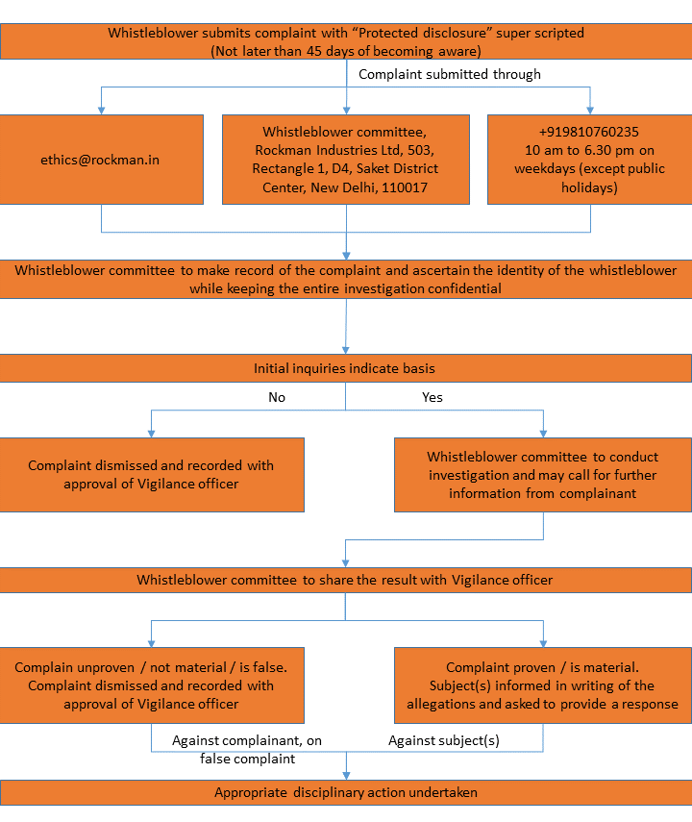
- PROCEDURE
  - Protected Disclosures should be reported to the Whistleblower Committee by the complainant as soon as possible after the whistleblower becomes aware of the same and in any case not later than 45 days after becoming so aware, so as to ensure a clear understanding of the issues raised and should either be typed or written in legible handwriting in English, Hindi or in regional language.
  - The Protected Disclosure should be submitted in a closed and secured envelope and should be super scribed as “Protected disclosure” or sent through email with the subject “Protected disclosure” or contact the phone number mentioned below. If the complaint is not super scribed and closed as mentioned above, unless and until the said super-scripting is beyond the complainant’s capabilities, it will not be possible to protect the complainant and the protected disclosure will be dealt with as if a normal disclosure.
  - The Protected Disclosure should be forwarded under a covering letter signed by the complainant. The Whistleblower Committee shall detach the covering letter bearing the identity of the whistleblower and process only the Protected Disclosure. In order to protect the identity of the complainant, the Whistleblower Committee will not issue acknowledgment to the complainants and they are advised neither to write their name/address on the envelope nor enter into any further correspondence with the Whistleblower Committee.
  - All Protected Disclosures should be addressed to the Whistleblower Committee to the email id: ethics@rockman.in or to the address Whistleblower Committee, Rockman Industries Ltd, 503, Rectangle 1, D4, Saket District Center, New Delhi, 110017 or on phone number +919810760235 during 10 am to 6.30 pm on weekdays (except public holidays)
  - Protected Disclosure against the member of the Whistleblower Committee or the Vigilance Officer should be addressed to the Exco members of Rockman who will then submit their report to the Nodal Officer after investigation.
  - On receipt of the protected disclosure the Whistleblower committee shall make a record of the Protected Disclosure and also ascertain from the complainant whether he was the person who made the protected disclosure or not, before proceeding with an investigation and needful action.
  - The Whistleblower committee if deemed fit may call for further information or particulars from the complainant.

- INVESTIGATION
  - All Protected Disclosures under this policy shall be recorded and thoroughly investigated. The Whistleblower committee shall carry out an investigation themselves or may at their discretion consider involving any other officer of the Company.
  - If the initial inquiries by the Whistleblower committee indicate that the concern has no basis, or it is not a matter to be investigated under this policy, it may be dismissed at this stage with the approval of the Vigilance Officer and the decision shall be documented.
  - The Whistleblower committee, if deems fit, may call for further information or particulars from the complainant and at its discretion, consider involving any other/additional Officer of the Company or an outside agency for the purpose of investigation.
  - Subject(s) will normally be informed in writing of the allegations at the outset of a formal investigation and have opportunities for providing their inputs during the investigation.
  - Subject(s) shall have a duty to co-operate with the Whistleblower Committee or any of the Officers appointed by it in this regard to the extent that such cooperation will not compromise self-incrimination protections available under the applicable laws.
  - Subject(s) have a responsibility not to interfere with the investigation. Evidence shall not be withheld, destroyed or tampered with, and witnesses shall not be influenced, coached, threatened or intimidated by the subject(s).
  - Unless there are compelling reasons not to do so, subject(s) will be given the opportunity to respond to material findings contained in the investigation report. No allegation of wrongdoing against a subject(s) shall be considered as maintainable unless there is good evidence in support of the allegation.
  - Subject(s) have a right to be informed of the outcome of the investigations.
  - The investigation by itself would not be tantamount to an accusation and is to be treated as a neutral fact-finding process.
  - The investigation shall be completed normally within 90 days of the receipt of the protected disclosure and is extendable by such period as the Vigilance Officer deems fit and as applicable.
- DECISION AND REPORTING
  - If an investigation leads to a conclusion that an improper or unethical act has been committed, the Whistleblower committee shall recommend to the Vigilance Officer to take such disciplinary or corrective action as it may deem fit.
  - Any disciplinary or corrective action initiated against the subject as a result of the findings of an investigation pursuant to this policy shall be in adherence with the rules, procedures, and policies of the Company.
  - A quarterly report with the number of complaints received under the policy and their outcome may be placed before the Audit Committee of the Company
  - A yearly report on the status of all Complaints received from the Whistleblowers, Complaints resolved and action taken, Complaints under investigation, and the number of false Complaints lodged may be placed before the Audit Committee of the Company
  - A complainant who makes false allegations of unethical & improper practices or about alleged wrongful conduct of the Subject to the Whistleblower committee shall be subject to appropriate disciplinary action in accordance with the rules, procedures, and policies of the Company
  - In case the Subject is the Vigilance Officer or the member of the Whistleblower committee, the Nodal Officer of the Company on the recommendation of exco members shall forward the protected disclosure to Audit Committee members if deemed fit. The Audit Committee Member shall appropriately and expeditiously investigate the Protected Disclosure.
  - If the report of investigation is not to the satisfaction of the complainant, the complainant has the right to report the event to the appropriate legal or investigating agency.
  - If the complaint does not fall under the purview of the whistleblower policy, then same would be redirected to the right forum. For e.g. – If the complaint is related to sexual harassment, same will be forwarded to the Complaints Committee and would be dealt as defined under Policy to Prevent Sexual Harassment at the Workplace. If complaint is related to a personal grievance, e.g. appraisal rating, promotion, etc. it will be forwarded to the relevant Chief Human Resource Officer.
- CONFIDENTIALITY
  - The complainant, vigilance officer, Whistleblower committee members, the subject and anybody involved in the process shall maintain the confidentiality of all matters under this policy, and discuss only to the extent or with those persons as required under this policy for completing the process of investigations and not keep the papers unattended anywhere at any time and keep the electronic mails/ files under password.
- PROTECTION
  - The whistleblower must disclose his/her identity in the covering letter forwarding such Protected Disclosure. Anonymous disclosures are not favored as it would not be possible to interview the Whistleblowers. However, when an anonymous Whistleblower provides specific and credible information that supports the complaint, such as alleged perpetrators, location and type of incident, names of other personnel aware of the issue, specific evidence, amounts involved, etc. while choosing to maintain anonymity, then there are often sufficient grounds for the Company to consider an investigation into the complaint. Any other employee serving as a witness or assisting in the said investigation would also be protected to the same extent as the Whistle Blower.
  - The Vigilance Officer and Whistleblower committee would safeguard the Whistle Blower from any adverse action. This includes discrimination, victimization, retaliation, demotion or adoption of any unfair employment practices.
  - A Whistle Blower may not be granted protection under this policy if he/she is subject of a separate complaint or allegations related to any misconduct.
- DISQUALIFICATION
While it will be ensured that genuine Whistle Blowers are accorded complete protection from any kind of unfair treatment as herein set out, any abuse of this protection will warrant disciplinary action.
Whistleblowers who make three or more Protected Disclosures, which have been subsequently found to be mala fide, frivolous, baseless, malicious, or reported otherwise than in good faith, will be disqualified from reporting further Protected Disclosures under this Policy. In respect of such Whistleblowers, the Whistleblower committee and the Vigilance Officer would reserve their right to take/recommend appropriate disciplinary action.
- COMMUNICATION
This policy cannot be effective unless it is properly communicated to all the existing Directors, and employees. It shall be informed by publishing it on HR portal and on the website of the Company.
- DISCLOSURE
The details of the establishment of such Whistle Blower Policy shall be disclosed on the website of the Company and in the Board’s report.
- PRESERVATION OF DOCUMENTS
All Protected disclosures in writing or documented along with the results of Investigation relating thereto, shall be retained by the Company for a period of 3 (three) years.

- ADMINISTRATION AND REVIEW OF THE POLICY
The Audit Committee of the Company shall be responsible for the administration, interpretation, application, and review of this Policy. The Audit Committee of the Company also shall be empowered to bring about necessary changes to this Policy, if required at any stage.
Any subsequent amendment/modification in the applicable laws in this regard shall automatically apply to this Policy.

